(*Some info is also taken from the video following this.*)

A **simple set** looks like this: {a, b, c, d}. Think of it as a bag, with each letter inside. Notice that this is the same as {c, a, b, d}, because order doesn’t matter. If you list an object twice in a set, it doesn’t matter as well, so {a, b, a, d, c} is okay too.

The **union of two sets** is putting the elements of two sets together, so assume {a, b, c, d} $∪$ {c, d, e, f} are two bags. If you are taking the union of them, you’re making a new bag with everything in both sets, so this would mean {a, b, c, d, e, f} or even {a, b, c, d, c, d, e, f}.

The **intersection of two sets** is similar, so assume {a, b, c, d} $∩$ {c, d, e, f}, where you’re finding which letters are in both of the sets. You’re making a new bag with only those that coincide, so you get the intersection set {c, d}.

The **empty set** has nothing in it (an empty bag). Two symbols to represent it include $⊘$ and { }.

A more complex set:{a, {b, c}, d, {e, {f}, g}, $⊘$, {$⊘$, h}, i}

* How many items are in this set?

a is 1 item, the set of bc makes that 2, d makes that 3, efg is 4th, the empty is the 5th, the empty h is the 6th, and i is the 7th item, so there are 7 items.

* What does this look like image-wise?

Think of bc as another bag inside of the entire bag (the entire complex set). For efg, f is a bag inside of the eg bag, which is in the entire bag. Next, the empty set is an empty bag, so that empty bag is in the entire bag. Continue this similarly with the rest of the elements:

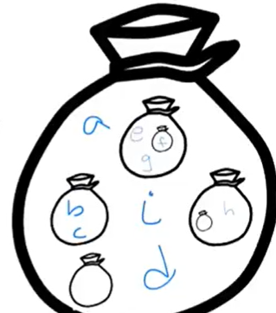

Another complex set: {a, b, c, {d, e, f}, $⊘$, {$⊘$}, g, h, i}.

* There are 9 items inside.
* Think how the empty set is also equivalent to curly braces, so {$⊘$} = {{ }}
* The following is a visual representation of what this looks like:

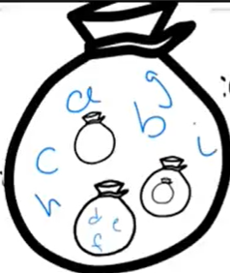

The union of these complex sets together:

* First, write out the first set again.

{a, {b, c}, d, {e, {f}, g}, $⊘$, {$⊘$, h}, i}

* Notice that in the second set, the b is in the bag (not in another bag within a bag, like the first one), so you can add in b and c to the set.

{a, {b, c}, d, {e, {f}, g}, $⊘$, {$⊘$, h}, i, b, c}

* The set within a set {d, e, f} is also not in the first set, so you must add that, along with the contained empty set.

{a, {b, c}, d, {e, {f}, g}, $⊘$, {$⊘$, h}, i, b, c, {d, e, f}{$⊘$}}

* See that g and h are, similarly to b, in the main set.

{a, {b, c}, d, {e, {f}, g}, $⊘$, {$⊘$, h}, i, b, c, {d, e, f}{$⊘$}, g, h}

The intersection of these complex sets together:

* Compare between the two sets and only choose what’s in the main bag, not the elements in the bags within the main bag! This answer is much shorter: {a, $⊘$, i}

Let’s take another set for an example: {a, b, c, {d}, $⊘$, {$⊘$}} (S1).

Is {a, b} (S2) a subset of the set? You can check. a and b are in both sets (and not in bags within bags and the like). So, $S2⊆S1$.

Is {a, b, d} (S3) a subset of the set? Notice how d is a bag within a bag in S1. This is not in the main bag, so $S3$ ⊈ $S1$.

Is {$⊘$} (S4) a subset of the set? Ask yourself, is everything in the empty set also in S1? Well, there’s nothing in the empty bag, so it’s in S1. Thus, $S4⊆S1$; additionally, it is a subset for *every* set, no matter what, even of itself. To see if something is a subset, check all the elements within both main bags. Here, there is nothing in the empty set to check with, so by default, it is a subset of any bag.

When asking about subsets, you must compare between two sets.

Let’s take the same set {a, b, c, {d}, $⊘$, {$⊘$}} (S1).

Is a an element of S1? a is an element of S1 if you can find an a inside of the main bag (S1). So can you? Yes, so a $∈$ S1.

Is {a} an element of S1? Ask, do you see a bag with an a in S1? No, so {a} $∉$ S1.

Is $⊘$ an element of S1? You see a bag with nothing in it in S1. So, $⊘∈$ S1. Note that this is not an element of every set because not every set has that empty bag within the main bag.

Is $⊘$ an element of {a, b}? Ask, do you see an empty bag in that set? No, so $⊘∉$ {a, b}.

Element VS Subset (simple)

Take the set example S7 = {a, b, c}.

Is a an element of S7? Firstly, notice that the thing on the right has to be a set, and the left doesn’t have to be a set but can be. So yes, it is (a $∈$ S7).

Is {a} an element of S7? There is not a set containing a in S7, so no, {a} $∉$ S7.

Is {a} (S8) a subset of S7? Yes ($S8⊆S7$) because both have a. Both sides of the equation *have* to be sets.

Is {a, b} (S9) a subset of S7? Yes ($S9⊆S7$) because both elements are in both sets. It’s true that both sides are sets. Go through everything in S9 and see if it’s in common.

Is S9 a subset of S8? Importantly, you always make sure that both sides are sets. a is in S8, but b is not in S8, so no, $S9$ ⊈ $S8$.

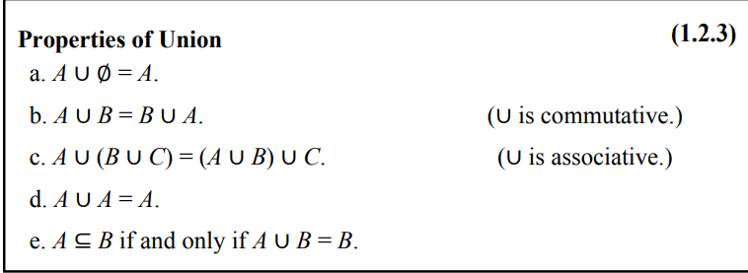

Commutative means you can move around elements and it’s still the same answer (order doesn’t matter). Associative means you can regroup elements and get the same answer (as shown in property C in both charts).

Note: A is a subset of B iff A $∪$ B = B because the only ways that can happen are if A is equal to B or if A has only some elements of B (and never additional elements that are not included in B). This is because in unions, duplicates can be eliminated (so if A has either some or all elements of B, or maybe has no elements at all) and it would just be equivalent to B. Thus, since A has a subset of elements that are a part of B, it is a subset of B.

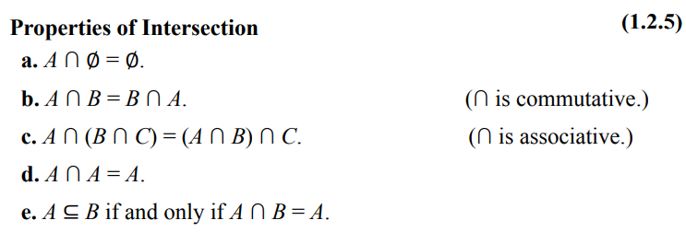

Note: A is a subset of B iff A $∩$ B = A because the only ways that can happen is if everything in A is also in B, which is the definition of a subset.